Okay. So now that we are a little bit more familiar with the interface and navigation, we can move on to manipulating objects within the 3D viewport. In this lesson, we're going to start learning some of the keyboard shortcuts that we are going to be using in Blender. So Teacher have downloaded an app that will display my keystrokes down here in the bottom left corner. We are going to be using a lot of keyboard shortcuts going forward.

So we have our starter cube here as marked below, and this is what is known as a mesh object.

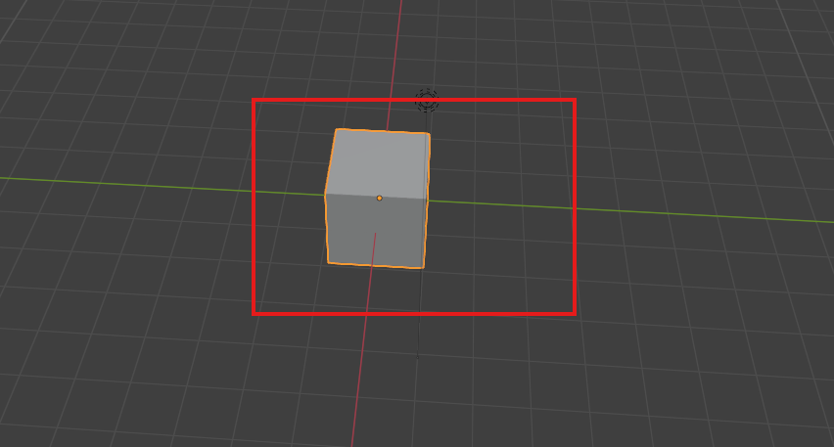

A mesh object is basically any 3D object that the computer renders using points in space called vertices to draw lines between called edges, which subsequently have faces drawn between them and are rendered opaque. Teacher will talk a bit more about vertices, edges and faces when we get into mesh editing. So in layman's terms, a mesh is basically any solid object that compromises the stuff in our 3D space. Everything that we model in this course is going to be a mesh object.

It's anything that isn't something like a camera or a light or a (non solid data type)(who knows). Mesh is often referred to as geometry. So you may hear me use those terms interchangeably. We're going to start by transforming the default cube. Transforming in the world of 3D graphics is just a way of collectively referring to the location, rotation and scale of an object in 3D space.

Press N on your keyboard to bring up the sidebar under item and then to transform panel as marked below.

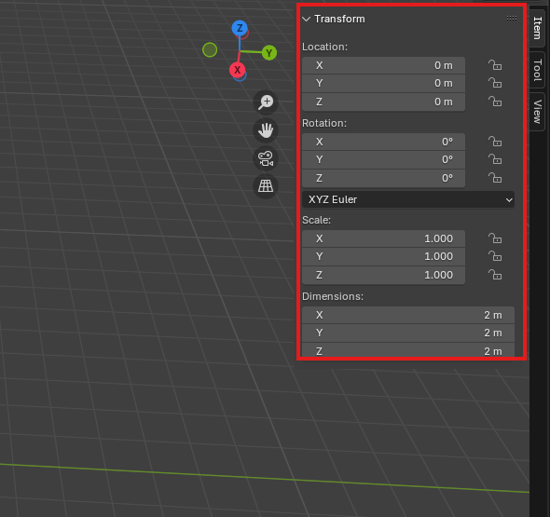

You'll see that this panel contains all those pieces of information of location, rotation and scale, as well as the dimensions of this object in real world space and real world units, which is driven by this scale value(property of transform) here.(Maybe the dimension is telling that whatever how much you scale the object the dimension will tell how much will the object will take space in real world in the current scaling in a particular parallel to axis.)

So we want to move this mesh around in our scene. All we have to do is select the cube by left clicking on it. The selection will be represented by this orange highlight around the edge here.as shown below

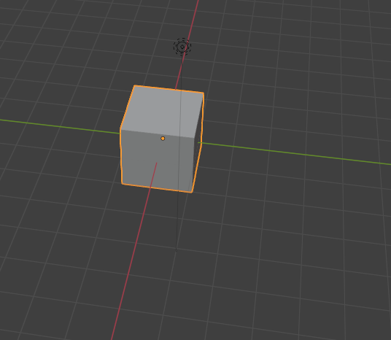

So once it's selected press **G** as in grab. And now you can see that when I move my mouse around, the cube moves with it and pointer shape changes to something which I could not record by snip. Very cool to drop the cube into a new location. Simply left click again when it's in the position that you want it. To drop the selection and cancel the operation while you're moving around. After pressing G **right click** and it will snap back to its original position to rotate. This right click way can be used in many circumstance where we want to undo something even in any software other than blender.(who knows)

3:00

Now to rotate an object then left click on the object that you want to rotate then hit R as in rotate and move the mouse to manipulate the object as shown below and then

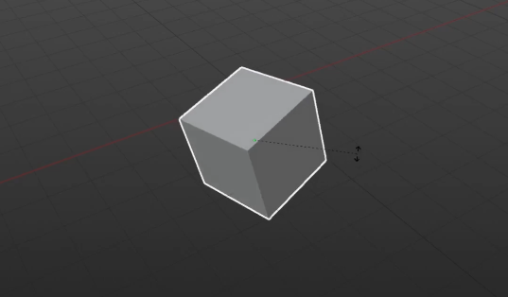

left click again to confirm the rotation of the object to scale an object selected by left clicking hit s as in scale and move the cursor away from the model to scale up as shown below

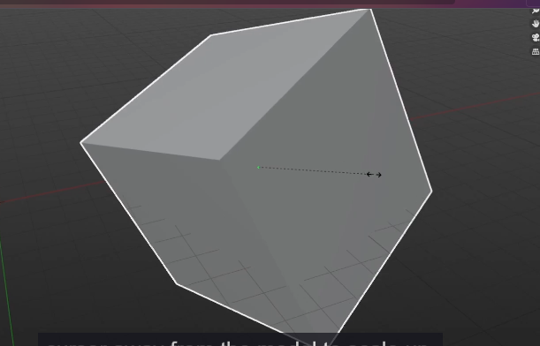

Now move across it towards the object to scale down. As shown below

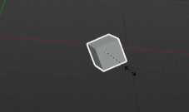

Once again, left click to confirm the new scale.

Teacher would just like to make a couple of quick additional points about scale.

In the world of 3D graphics, the size of something it's referred to as its scale and scale works as a decimal system.

When you add a new primitive object.

Now when you see in the pop that is visible by pressing N

Now we can see the selected object scale in this case cube

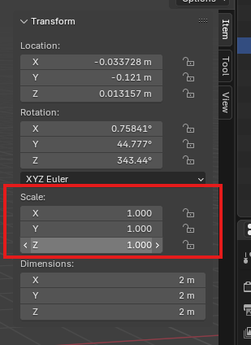

It will have a scale of one in all directions in X and Y and Z.

__________________________________________________________________________________

**Note:-**

To create a primitive mesh object press **Shift + a** on any empty space in 3d viewport

And then a submenu will be opened click on mesh and then in next submenu choose any predefined

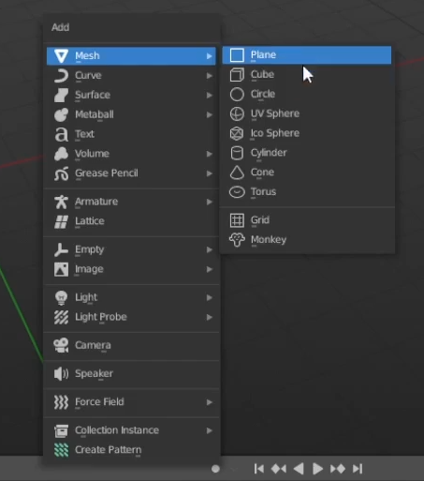

Mesh object you want

The default cube primitive is added to the dimension with a scale of one, but dimensions of two metres but dimension of two metres by two metres by two metres, meaning it is two metres long and the x direction two metres long in the y direction and two metres long in the z direction.(maybe if they were in the real world )

Now this object is of scale of 1 for this cube object so we make the scale 2 in all direction in n popup

We change scale in N popup in x direction Now it will look like below

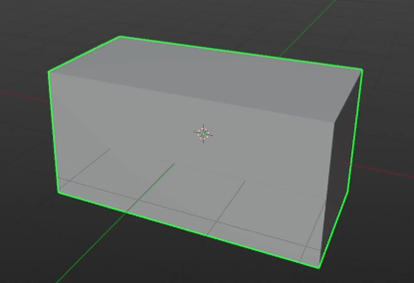

We change scale in N popup in y direction Now it will look like below

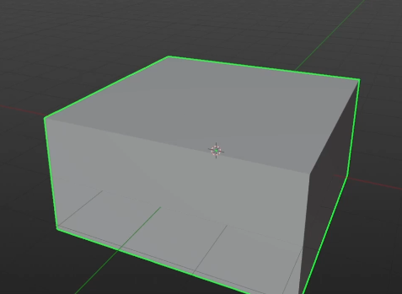

We change scale in N popup in z direction Now it will look like below

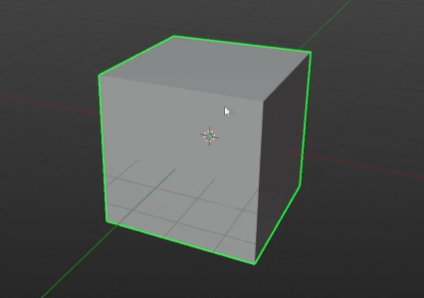

We now have a cube that is twice the size and we can see that reflected here in the dimensions where it says four metre by four metre by four metre because four is twice of two as marked below

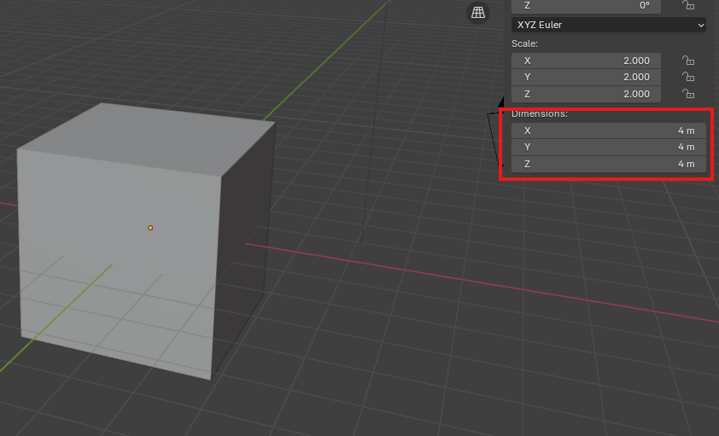

because four is twice of two.

Giving the original object of scale of 0.5

__________________________________________________________________________________

**Note:-**

If we press s by left click then it will scale but you can also give it some value while doing so and whatever numerical value you will type that will be the nx of selected object in all axis

For example you press 2 then the result and object will be 2x

Now if we scale our cube object of scale 1 by s method then while scaling by this we type 0.5 then it will look like below

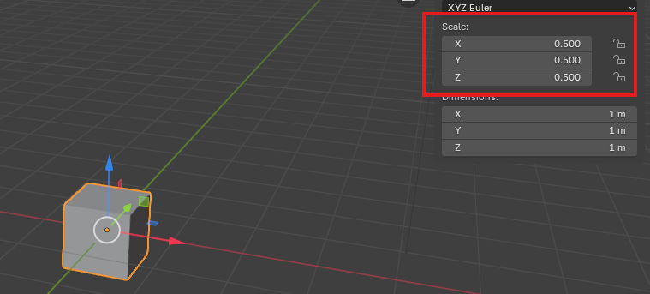

You can see the scale as marked above and you can see it is 0.5 in all axis

And also you can see the dimension of one metre by one metre below the marked

And as a side note, Teacher have units for blender set to metres. If it's not set two metres for you, don't worry. At this point it really doesn't matter what units you're using here.

But if you want it to be in other just for ease of following along, you can set the world units by coming into the properties in the right hand side go to the scene properties as marked below , Go under units. And you can set oy here just make sure that the unit system is metric. The unit scale is one and the length is in meters or you can set it to other units like centimeters, kilometers and anything you want as shown below when you open the length submenu

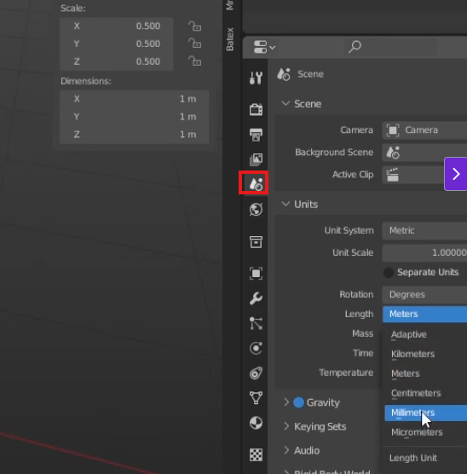

All this means is that now within the 3D viewport, one of these grid lines Is equal to one square meter. All this means is that now within the 3D viewport, one of these grid lines is equal to one square meter(I don’t think it does work like that anymore and I think it just effect the unit of dimension ( who knows )). You can see below image to see how a cube of dimension of 1 in all axis fit the section grid so perfectly as shown below

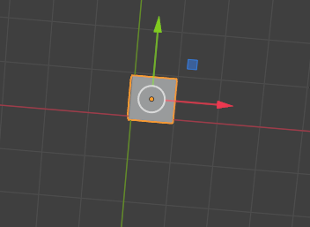

6:20